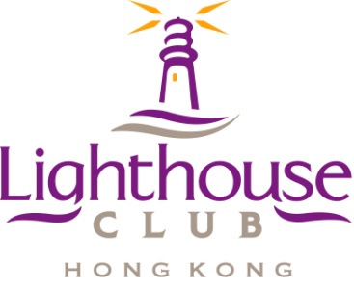

Supporting Organisation

##### SAFE SUBCONTRACTOR AWARDS 2014

# 1. The Process: Subcontractors working in the Hong Kong Construction Industry, are invited to enter the Lighthouse Club Safe Subcontractor Awards 2014 by completing the ‘Application Form’ and sending it to the Lighthouse Club Administrator (email: [lighthousehkg@gmail.com](mailto:lighthousehkg@yahoo.com)) by the application deadline.

An inspection of the subcontractor must be conducted by a Registered Safety Officer and submitted with the application for the award on the ‘Site Visit’ provided.

The Award Committee will shortlist candidates for the 1st and Final round on-site judging assessments.

A final decision on the award result is made by the Awards Committee and confirmed by the Lighthouse Club Safety Committee.

The Awards will be announced, and presented, at the Lighthouse Club Contractors' Dinner, scheduled for 12th September 2014.

2. **Basic Requirements of Candidate Companies:** The candidate company shall not have any safety convictions during the **past two years** and no fatal accidents during the **past three years**. The candidate company will be a registered subcontractor under the Voluntary Subcontractor Registration Scheme.

# 3. The Deadline for Entries: The deadline for submitting entries for the awards is 15th July 2014. The Lighthouse Club Safety Committee may extend this deadline at their discretion.

# 4. The Award Committee: The Award Sub-Committee comprises members of the Lighthouse Club Safety Committee and members of HKOSHA.

# 5. Short-listing and Judging of Candidates: 10-12 candidates will be short-listed for an initial site inspection by nominated Registered Safety Officers, between 18th – 29th August 2014. A second short-list of 5 candidates will be prepared based on the initial site inspection and a final round site inspection carried out by members of the Award Sub-Committee. During the on-site inspection candidates will be expected to briefly present details of their safety management system, provide documentary evidence, arrange a site visit and allow the judges to interview personnel (reference to the ‘Inspection Form’ should be made).

6. **The Award:** All award winners will receive a trophy and a certificate.

The first place winner will win a sponsored gala dinner (or equivalent). All award winners will receive a 1 year Lighthouse Club corporate membership (effective on submission and approval of a standard corporate membership application). Other prizes for 2nd to 5th places are to be confirmed.

# 7. The Award Ceremony: The presentation of the Safe Subcontractor Awards 2014 will take place at the Contractors' Dinner on 12th September 2014.

 Safety Partner:-