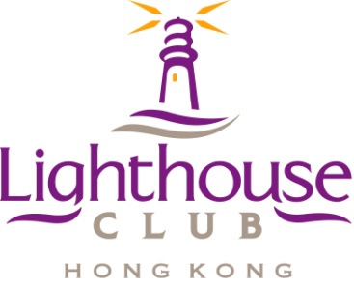

Supporting Organisation

##### SAFE SUBCONTRACTOR AWARD 2014

ENTRY FORM

# (Entry deadline 15th July 2014)

*Note: The requirement for nomination by a client or main contractor was removed in 2013 to encourage a wider range of subcontractor’s to enter the awards.*

## 1. Candidate’s Details

|  |  |  |  |  |
| --- | --- | --- | --- | --- |
| Name of the Company |  | | | |
| Name of the Managing Director/General Manager |  | | | |
| Name of Contact Person |  | |  | |
| Contact Details | Tel.: | | Email: | |
| Address: | | | |
| Type of Work Carried Out |  | | | |
| Main Projects Involved in |  | | | |
| Project to be considered for the award | *Note: Judging period 19th July to 6th September* | | | |
|  | | | |
| Contact Details of Client/Main Contractor on the above project(s) | Company Name: |  | |  |
| Contact Person: |  | |  |
| Telephone: |  | |  |
| Email: |  | |  |

*Note: You will need to get approval from the client/main contractor for LHC to access the project site to carry out the judging assessments.*

**2. Inspection by a Registered Safety Officer**\*

|  |  |
| --- | --- |
|  | Inspection Report attached (on the Lighthouse Club Form) |
|  | Inspection Report to be submitted by 15th July 2014 |

*Tick as appropriate

Signature of Subcontractor’s Representative:

_____________________________ Date: _________________

Safety Partner:-