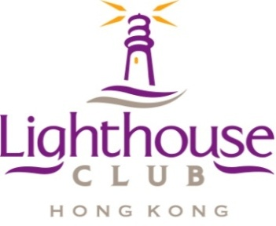

Supporting Organisations:

SAFETY PRACTITIONER AWARDS 2014

# 1. The Process

Site Safety Professionals working in the Hong Kong Construction Industry are invited to enter the Site Safety Professional Awards. These individuals will be senior frontline safety personnel working on construction sites in Hong Kong and may include: senior safety officers, safety managers etc.

The candidate shall submit the ‘application form’, including a referee’s statement and attaching requested documentary evidence.

The Awards Committee will shortlist candidates for the final round assessment which comprises the attending of an interview and, for the finalists a visit to their workplace by a nominated inspector. The final decision will be made by the Awards Committee and endorsed by the Lighthouse Club Safety Committee. The Award will be announced, and presented, at the Lighthouse Club Contractors' Dinner, scheduled for 12th September 2014.

# 2. Basic Requirements of Candidate for the Nomination

The candidate shall…

* Be a Registered Safety Officer or Chartered Safety Professional or Equivalent
* Have 5 years post-qualification experience in health and safety
* Have 3 years working experience in the Hong Kong Construction industry
* Be currently employed in the Hong Kong Construction Industry.

# 3. The Application

The deadline for submitting the application and all supporting documentation is **15th July 2014** to the Lighthouse Club Administrator (email: [lighthouseclubhkg@gmail.com](mailto:lighthouseclubhkg@yahoo.com)). The deadline may be extended at the discretion of the Awards Committee.

# 4. The Awards Committee

The Awards Committee comprises members of the Lighthouse Club Safety Committee, the Society of Registered Safety Officers and Hong Kong Occupation Safety and Health Association.

# Safety Partner:

# 5. Short-listing of Candidates

Up to 10 candidates will be short-listed for an initial interview by members of the Awards Committee. Based on the initial interview 5 finalists will be chosen and inspections of their place of work arranged by representatives of the Awards Committee. The finalists may be required to attend a 2nd interview at the discretion of the Awards Committee. The Awards Committee will propose the final results to the Lighthouse Club Safety Committee for approval.

# 6. The Award

All top prizes winners will receive a trophy and a certificate.

The first prize winner will win a 1 ounce gold nugget, 2nd place = HK$5,000, 3rd place = $3,000, 4th place = $2,000, 5th place = $1,000. In addition all winners will receive a 1 year individual membership to the Lighthouse Club Hong Kong (applicable after submission and approval of a standard individual membership application).

# 7. The Award Ceremony

The presentation of the Safety Practitioner Awards 2014 will take place at the Contractors' Dinner on 12th September 2014. Main Contractors, Subcontractors and many other related organizations will be invited to attend.

