SOCIETY OF REGISTERED SAFETY OFFICERS
註冊安全主任協會

Website: www.srso.org.hk

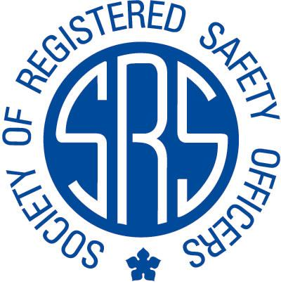

SRSO Application Form for OSH Seminar

Date : 10 May 2019 (Friday)

Time : 19:00 –20:30 *(18:45 for registration)

Speaker : Mr. Michael Leung

Topic : From Safety-I to Safety-II: Improvement or Backsliding in the Measurement of Safety Performance?

Venue : Construction Innovation and Technology Application Centre
(CITAC) Seminar Room, Kowloon Bay, Kowloon.

*Name : ________________________________________ ( )

*SRSO Member : Yes / No *SRSO Member No: ________

*Contact Telephone No.: _________________ *Fax: __________________

*E-mail : __________________________________

*Mailing Address:

_____________________________________________________________________

_____________________________________________________________________
*Attendant Certificate : Yes / No
Title: From Safety-I to Safety-II: Improvement or Backsliding in the Measurement of Safety Performance?

Date: 10 May 2019 (Friday) 7:00 pm to 8:30 pm

Medium of Speech: Cantonese

Brief: The traditional yardstick in measuring and awarding good safety performance of an organization over the current year revolves around the concept of ZERO HARM which, more often than not, is through benchmarking its accident frequency rate and / or fatality rate against those of the organization itself, or the Government, for the previous year. However, the absence of accident does not necessarily imply the absence of risk. This approach is categorically called Safety-I while in recent years the alternative concept of Safety-II prevails in some European countries, in particular in the aviation and medical fields. Safety-II alternatively concentrates on measuring successes (non-accident accomplishments) instead of failures (accidents). Whether this is a more meaningful mode of measurement is still subject to more stringent verifications and acceptance by the wider community.

Bio of Speaker
Leung Chiu Ming, Michael started his career in occupational health, safety and environmental sustainability back in 1979 as a Factory Inspector of the Labour Department, and has since worked in various sectors including telecommunications, tertiary education and construction. He is currently a safety practitioner working for a curtain wall subcontractor.

Registration & Enquires:

The seminar is free of charge for members who have settled the Annual Fee(s). Non-members will be charged HK$100.00 for the attendance and CPD certificate. (All application forms from non-members requiring attendance certificates must be accompanied with a cheque in the amount of HK$100.00 payable to Society of Registered Safety Officers. Otherwise, no attendance certificate will be issued.) Due to the limited number of space (Max. 30Nos.), enrolment will be given on a first-come-first-serve basis. Please return the application form by e-mail: srso@srso.org.hkk. Successful applicants will be notified in due course. For any enquiry, please contact Mr. Patrick LI at (852) 2793-3929 or e-mail: srso@srso.org.hk.

Remark:
- The applicant must fill in the application form fully and send by e-mail. SRSO will reject those applicants who do not properly complete the application form or who apply late.

- SRSO will not issue the attendance certificate to those applicants who arrive late for 30 minutes or more. SRSO reminds successful applicants to attend on time.

- SRSO CPD Certificate is invalid without the SRSO (Activities (A/B)) Chop.

