:  | 
Certificate Training Workshop: Risk Management And Safety Engineering I – Fundamentals
Duration: 18 hours
Date & Time: 3, 10, 17, 24, 31 March and 14 April 2012 (Saturdays)
14:00 – 17:00 (13:30 registration)
Venue: the Hong Kong polytechnic University
Fee: HK$ 1800 Non Member
(including refreshment) HK$ 1600 for Supporting Originations: HKIE-SSC, FOSHA, SOEHK, CCPDC, SRSO
HK$ 1450 for PolyU–ME students and Staff (First 6 enrollments free of charge), IMechE and HKARMS members
Who should attend: All managers, engineers, operators and safety officers, or anyone with a responsibility for understanding, practicing and implementing risk management and safety assessment.

ABOUT THIS COURSE

Making informed decisions requires understanding of risk and benefits of our alternatives, the technology involved and the factors affecting our decisions. Risk management and safety engineering is a discipline that provides the technique and tools to evaluate the effects and benefits or engineering decision alternatives, allowing decision makers to make risk-informed decision. This Risk Management and Safety Engineering Certificate Course consists of a series of training workshops that covers the key techniques and tools commonly use in risk assessment and decision-making analyses.
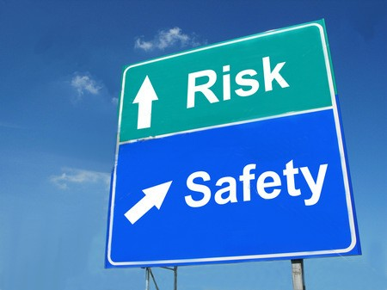
This introductory course, which is the first of the series providing structured, applied and practical approach in conducting risk assessments and decision analyses, addresses the basic concept and theory in Risk Management and Safety Engineering, as well as providing an overview of the common tools and techniques in safety risk assessment. This course is necessary for participants to capture the basic knowledge for future workshops on Intermediate and Advanced Topics in Risk Management and Safety Engineering course.

We have invited experts from the industry to deliver the workshop, their short bio is available at http://www.imechehk.org.hk/

The workshop consists of 6 sessions. Work examples and case studies will be used to aid participants in understanding the applications of the tools and analysis. The content and schedule are as follows:

CERTIFICATE TRAINING WORKSHOP:
RISK MANAGEMENT AND SAFETY ENGINEERING I – FUNDAMENTALS
Session 1 by Dr Vincent Ho  Date: 3 March 2012 (Sat) 2-5pm  Venue: PolyU CD-307 | Introduction to Risk Management and Safety Engineering, definition of risk, risk acceptance criteria, risk management principles.
Session 2 by KH Tan  Date: 10 March 2012 (Sat) 2-5pm  Venue: PolyU BC201 | Basic risk identification tools, e.g; Failure Mode and Effect Analysis, HAZOP, HAZID and applications of risk matrix etc.
Session 3 by Lisa Shi  Date: 17 March 2012 (Sat) 2-5pm  Venue: PolyU N002 | Overview of Bow Tie analysis in risk management.
Session 4 by Dorothy Chan  Date: 24 March 2012 (Sat) 2-5pm  Venue: PolyU CD309 | Basic human factor tools used in risk assessments, e.g Human factor and human reliability analysis.
Session 5 by Dr Vincent Ho  Date: 31 March 2012 (Sat) 2-5pm  Venue: PolyU PQ304 | Bayesian data analysis, introduction to decision analysis and analytical hierarchical process (AHP).
Session 6 by Dr Vincent Ho  Date: 14 April 2012 (Sat) 2-5pm  Venue: PolyU PQ304 | Overview of tree tools such as fault tree analysis and event tree analysis.
*Speakers information is for reference, the speaker of each session will be subject to the speaker’s availability.

- Enrolment Method
- Please register online at: http://www.hkarms.org/Registration/EventRegister.php?Event=40
- Registration by email will not be entertained
- Request for payment will be issued by email
- Enrolment deadline is 27 Feb 2012.
- Payment Method
- Please send cheque with payee name “The Institution of Mechanical Engineers - Hong Kong Branch
IMechE Hong Kong Office,
Room 1606, 16/F Dominion Centre, 43-59 Queen's Road East, Wanchai, Hong Kong
Remember to write down your name at the back of the cheque for verification.
- Please check our website for the updated list of supporting organisation of this workshop.
- All payments are non-refundable once enrolment is accepted through e-mail confirmation.
- Successful registrant will be notified by email.
- A receipt will be issued upon request.
- Notes
- All registrations are administered through IMechE Hong Kong Branch.
- Enrolment is first-come-first-served basis and will be confirmed upon receipt of payment.
- Priority will be given to members.
- Certificate of Attendance will issues at the end of the course upon completion of at least 80% of the course.
- Please show your confirmation email for registration at the session.
- Enquiry
For further enquiries, please contact IMechE Hong Kong Branch at
- Tel : 3153 4182 / 3153 4186
- Fax : 2894 9885
- E-mail: imeche@imechehk.org.hk
- Website : http://www.imechehk.org.hk/

